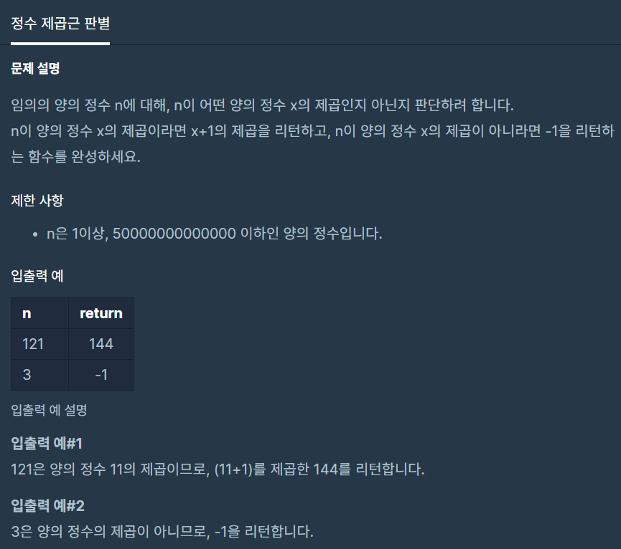

**문제 링크주소 :** <https://programmers.co.kr/learn/courses/30/lessons/12934>

**풀이**

function solution(*n*) {

    var answer = 0;

    var i =1;

    while(i>=0){

        if(i*i == *n*){

            answer = (i+1)*(i+1);

            break;

        }

        else if(i>=*n*){

            answer = -1;

            break;

        }

        else {

            i++;

        }

    }

    return answer;

}